This is a short document showing the testing of the user input. In this test in a Letter outside of the range A-H or a number outside of the range 1-9 is entered, the error message appears asking the user to input this coordinate again. If successful the script continues on to the movePiece() function. If the move the user has entered does not comply with Ruairi’s moveLegal() function, the error message will appear and the board will stay the same, returning to the start of the users go again.

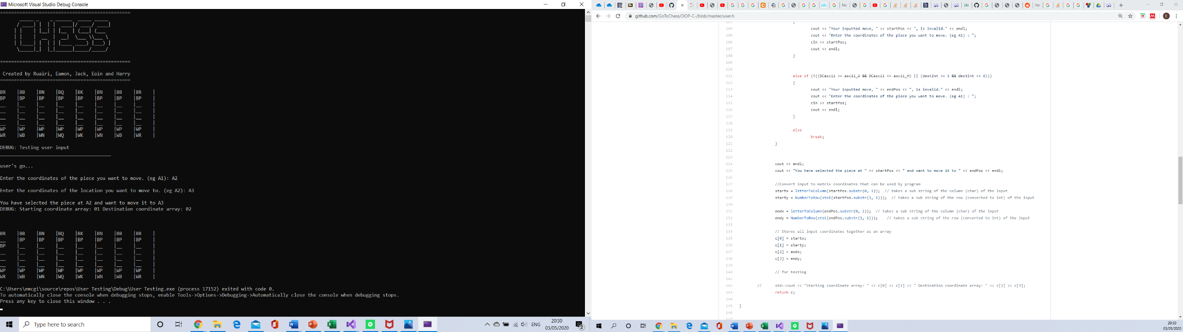This screenshot shows the successful outcome if the user inputs a correct move and will continue to the computers turn.